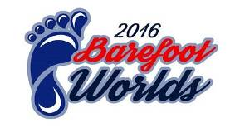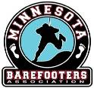
2016 World Barefoot Water Ski Championships presented by Bank First
August 13-20 2016 Alma Center, WI USA
INTENTION TO COMPETE
We intend to enter the following team and/or individual skiers to the above World Barefoot Championships:
FEDERATION:
DIVISION | OPEN |  | JUNIOR |  | SENIOR
Team Skiers | MALE | FEMALE | MALE | FEMALE | MALE | FEMALE
SLALOM
TRICKS
JUMP
Independent Skiers | MALE | FEMALE | MALE | FEMALE | MALE | FEMALE
SLALOM
TRICKS
JUMP
Contact Person: email:

Please return this form as soon as possible or prior to the deadline of June 18th, 2016 to the following people:
Doug Bohn - Local Organizing Committee Registrar registrar@mnbarefooters.org
Richard Gray – Chairman WBC g1footer@aol.com
Any Federation not meeting this requirement shall not be allowed to compete until they pay a fine of $200 (USD) to the World Barefoot Council.
Doping control
In accordance with the IWWF anti-Doping Rules, Doping controls will be conducted during the competition. By entering this competition, all athletes agree to be subject to doping control.
Information about the IWWF Anti-Doping program, the current IWWF AD Rules and links to the list of banned substances can be found on http://www.iwwfed.com/ by clicking the Anti-Doping Information link at the top of the menu on the left sidebar of the homepage.
